Using Typescript in your SPFx Webpart

1. To create a new web part project

* Create a new project directory in your favourite location.
* Open command prompt
  + Run as administrator

***md TypescriptWebpart***

1. Go to the project directory

*cd* ***TypescriptWebpart***

1. Create a new ***TypescriptWebpart*** by running the Yeoman SharePoint Generator.

yo @microsoft/sharepoint

**When prompted**:

* Accept the default **typescript-webpart** as your solution name, and then select Enter.
* Select SharePoint Online only (latest) and select Enter.
* Select Use the current folder for where to place the files.
* Select N to not allow the solution to be deployed to all sites immediately.
* Select N on the question if solution contains unique permissions.
* Select WebPart as the client-side component type to be created.

**The next set of prompts ask for specific information about your web part:**

* Accept the default HelloWorld as your web part name, and then select Enter.
* Accept the default HelloWorld description as your web part description, and then select Enter.
* Accept the default No JavaScript web framework as the framework you would like to use, and then select Enter

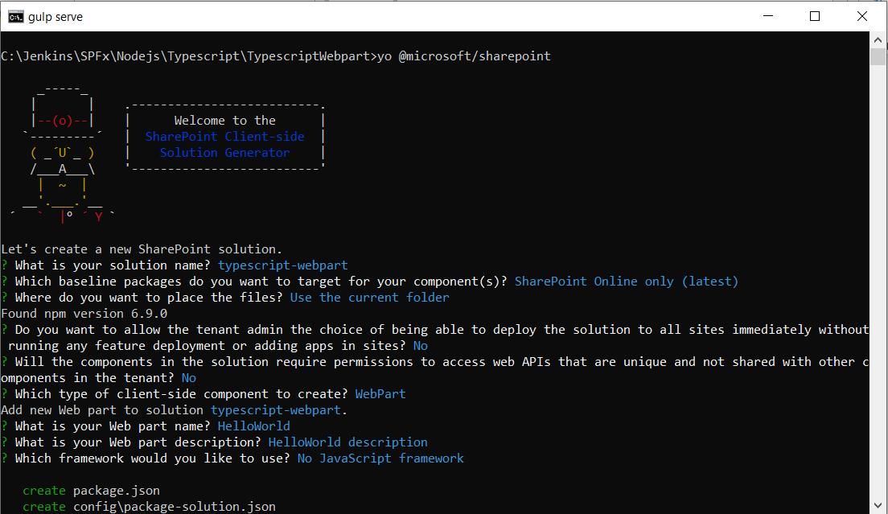

1. Now you know the files highlighted below

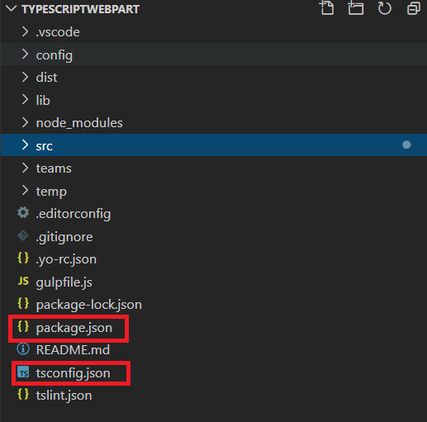

1. tsconfig.json to manage typescript execution
2. package.json to manage dependencies and starting point
3. Create a Components folder under src i.e src 🡪 Components
4. Then create two files under component folder
   1. IPerson.ts
   2. module1.ts
5. Open IPerson.ts and paste below code

export interface IPerson {

fristname: string;

lastname: string;

}

1. Open module1.ts and paste below code

export let age : number = 20;

export let strval : string = "Data from module";

export class employee {

private empCode: number;

private empName: string;

constructor(name: string, code: number) {

this.empName = name;

this.empCode = code;

}

public displayEmployee() {

console.log ("Employee Code: " + this.empCode + ", Employee Name: " + this.empName );

return("Employee Code: " + this.empCode + ", Employee Name: " + this.empName );

}

}

1. FYI : In module1.ts file I have added one class-employee, one string variable - strval and one number variable - age
2. Save all
3. Open HelloWorldWebPart.ts file
4. Import module

import * as employeeinfo from'./../../Components/module1';

import {IPerson} from './../../Components/IPerson';

1. Add a constant value to pass interface object

const username = {

fristname: "Jenkins",

lastname: "NS"

};

1. Find **public render(): void {**

add below code next to render():void

let fullname = this.welcomeuser(username);

let empinfo = new employeeinfo.employee('Oliver', 10);

let empinforeturn = empinfo.displayEmployee();

1. Replace this.domelement.innerHtml = `… up to end

</div>`;

this.domElement.innerHTML = `

      <div class="${ styles.helloWorld }">

    <div class="${ styles.container }">

      <div class="${ styles.row }">

        <div class="${ styles.column }">

          <span class="${ styles.title }">${fullname}</span>

          <span class="${ styles.title }">${empinforeturn}</span><br>

          <span class="${ styles.title }">Age : ${employeeinfo.age}</span>

          <span class="${ styles.title }">String Value : ${employeeinfo.strval}</span>

          </div>

          </div>

          </div>

          </div>`;

1. Add a method below the render method – to call **welcomeuser**

protected welcomeuser(user: IPerson): string

{

console.log(`Hey ${user.fristname} ${user.lastname} - Welcome to SPFx training`);

return `Hey ${user.fristname} ${user.lastname} - Welcome to SPFx training`;

}

1. Compile and run the webpart
2. Open the command prompt or Terminal
3. Type **gulp serve**
4. It will open a localhost workbench
5. And display the output like below

